CHW3M World History to the 16th Century
Final Exam Prep January 2011
Exam will be held in room 132 Tuesday 2 February 2011.

The exam will have two parts. Part I will be a mapping exercise and Part II will be a long answer writing component.
You will be allowed to bring in the 2 lined cue cards provided to you filled with notes to assist you.
The exam will comprise of writing 2 informal essays (using essay format but citations not required even if you use quotes). The first mini-essay will deal with content knowledge and the second essay will deal with overarching themes and speak to the ideas of continuity and change. Names and dates are important for the strength of your argument and your mark.
Each essay will be worth 40 marks for a total of 80 marks.
Marks will be allotted as follows:
Essay format (introduction, body paragraphs in the order you stated in your introduction, conclusion). 3 marks
Strong thesis statement within the first three sentences of your introduction. 4 marks
Introduction clearly tells the reader the order of your supporting ideas (how you will defend/support your thesis). 3 marks
Conclusion restates your thesis and sums up your supporting argument. 3 marks
Correct spelling of key terms (names, events, locations). 2 marks
There are a minimum of three clear supporting idea paragraphs with at least three specific details to defend each of them. 15 marks maximum
Three civilizations or more used to strengthen your argument. 5 marks maximum
Five specific names and / or key dates included. 5 marks

Good luck and have fun with it!! Don’t be afraid to think outside the box.

PART I
Locate and label 30 items from the list below on the map provided you. 30 marks
Acre Gaul Persian Gulf
Ahketaton Greece Red Sea
Alexandria Hastings Rhine River
Alps Iberia Rome
Antioch Jerusalem Knossos
Arabia Libya Salamis
Athens London Sicily
Atlantic Ocean Macedonia Sparta
Attica Marathon Syracuse
Babylon Mecca Thebes
Black Sea Megara Thermopylae
Cairo Mesopotamia Mediterranean Sea
Carthage Mt. Olympus Troy
Constantinople Nile River Valley of the Kings
Corinth Nile Delta Mycenae
Crete Normandy
Eastern Desert North Sea
Egypt Nubia
Euphrates River Palestine
Faiyum Peloponnese
Gizeh (Giza) Persia
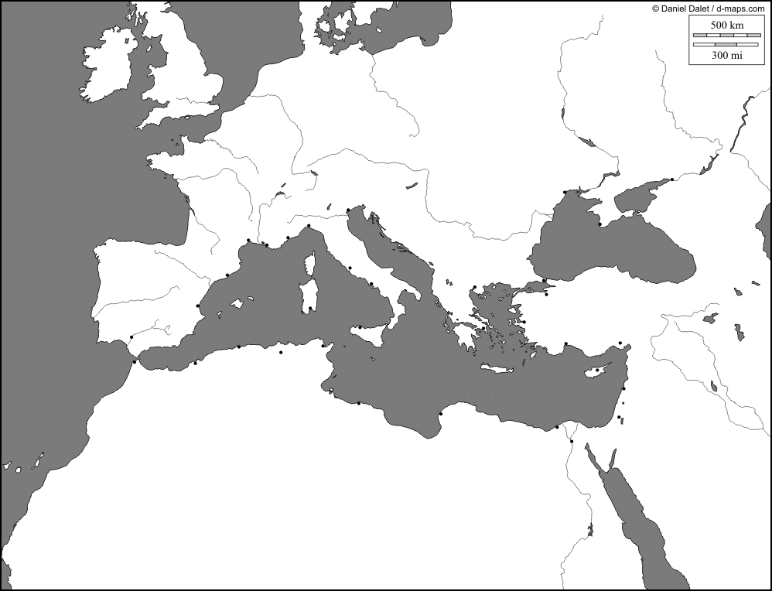
PART II
PART A:
Select ONE of the following prompts and respond to it in an essay drawing evidence (specific detailed examples) to support your viewpoint from at least 3 civilizations you have learned about in this course:
- Military skill and technology is essential for the success and longevity of a civilization.

- Select what you believe to be the most vital criteria for a civilization to possess in order to be “great” and explain why.

- Choose a great leader from the civilizations you learned about in this course and explain why they were great and should be remembered (historical significance). Include who they were, when they reigned, what civilization they ruled, their accomplishments, lasting impact to theirs and other civilizations and elements of their character that made them great. Use other civilizations’ leaders to contrast and strengthen your argument.

- If you could live in any civilization (consider whether you are male or female), which would it be and why?

- Studying the mythology and/or beliefs of a civilization is an integral part of the study of history. Draw upon the myths, and the civilizations that created them, that we have explored in this course to defend or refute this statement.

- Geography is a major factor that influences the level of greatness or success of a civilization.

PART B:
Select ONE of the following prompts and respond to it in an essay drawing evidence (specific detailed examples) to support your viewpoint from at least 3 civilizations you have learned about in this course:
- Through our study of world history to the 16th Century we have learned about the rise and decline of many civilizations. Why is this so?

- It is thought by many that our civilization is the most advanced humans have ever been. Agree or dispute this drawing upon the civilizations you have learned about in this course.

- Choose one civilization and explain why they rose above others.

- Choose one civilization and explain why they declined or even disappeared all together.

- If all great civilizations have their “turn” to dominate and assuming they will inevitably decline, when is our turn to fall and how and why will it happen?

- All great civilizations inevitably fall. Agree with or dispute this statement.

- Do any civilizations stand alone and owe nothing to previous civilizations or their current counterparts: can any civilization thrive without being influenced by others or impacting another?

- Looking back, speak to the idea of change and continuity. What things have changed and what things have continued from the dawn of human existence with minimal change? Are we really that different from those who came before us?

