Principal gods of Greek mythology
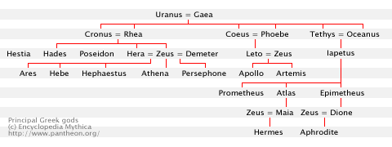
Note: Hephaestus is often said to be only Hera's son, and Aphrodite is usually said to be born of sea foam.
Source: Edith Hamilton. Mythology: Timeless Tales of Gods and Heroes. New York: Mentor, 1940. ISBN: 0451628039.
Zeus' consorts and offspring
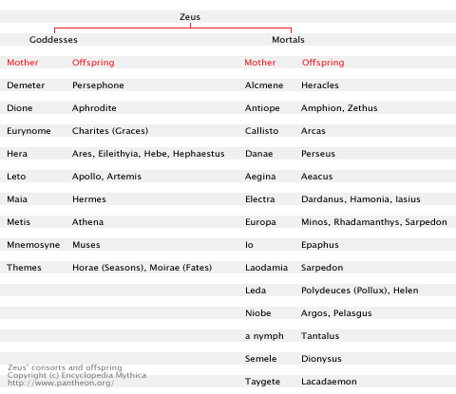
Note: This is only a small part of Zeus' many lovers and their offspring. The number of his consorts, and nymphs he abducted and fathered children on, is well over a hundred. Covered here are the most important ones.

Descendants of Prometheus
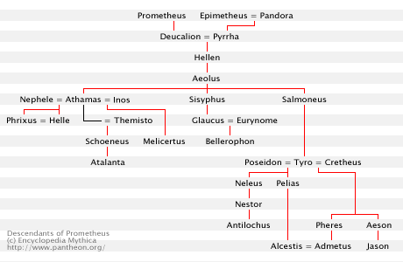
Source: Edith Hamilton. Mythology: Timeless Tales of Gods and Heroes. New York: Mentor, 1940. ISBN: 0451628039.

Greek vs Roman
The (major) Greek deities and their Roman counterparts.
Greek name | Roman name
Amphitrite | Salacia
Ananke | Necessitas
Aphrodite | Venus
Ares | Mars
Artemis | Diana
Asclepius | Aesculapius
Asclepius | Veiovis
Athena | Minerva
Atropos | Morta
Boreas | Aquilo
Charites (Graces) | Gratiae
Chloris | Flora
Clotho | Nona
Cronus | Saturn
Demeter | Ceres
Dionysus | Bacchus
Enyo | Bellona
Eos | Aurora
Eos | Matuta
Erinyes | Furies
Eris | Discordia
Eros | Cupid (Amor)
Eurus | Vulturnus
Gaia | Tellus
Galinthias | Galinthis
Irene | Pax
Hades | Dis Pater, Pluto, Orcus
Hebe | Juventas
Hecate | Trivia
Helios | Sol
Hera | Juno
Heracles | Hercules
Hermes | Mercury
Hephaestus | Vulcan
Hesperos | Vesper
Hestia | Vesta
Hygieia | Salus
Hypnos | Somnus
Lachesis | Decima
Leto | Latona
Moirae (Fates) | Parcae
Nike | Victoria
Notus | Auster
Odysseus | Ulysses
Pan | Faunus
Persephone | Proserpina
Pheme | Fama
Phosporus | Lucifer
Poseidon | Neptune
Satyr | Faun
Selene | Luna
Semele | Stimula
Silenus | Silvanus
Themis | Justitia
Tyche | Fortuna
Zephyrus | Favonius
Zeus | Jupiter

http://www.pantheon.org/miscellaneous/greek_vs_roman.html © copyright MCMXCV - MMVII Encyclopedia Mythica.

